Eskom Kimberley Strengthening Phase 4 Project

Application 4: Manganore - Ferrum
(DEA Reference– 14/12/16/3/3/2/644))

Final Specialist Report for the Environmental Impact Phase

Bird Impact Assessment Report
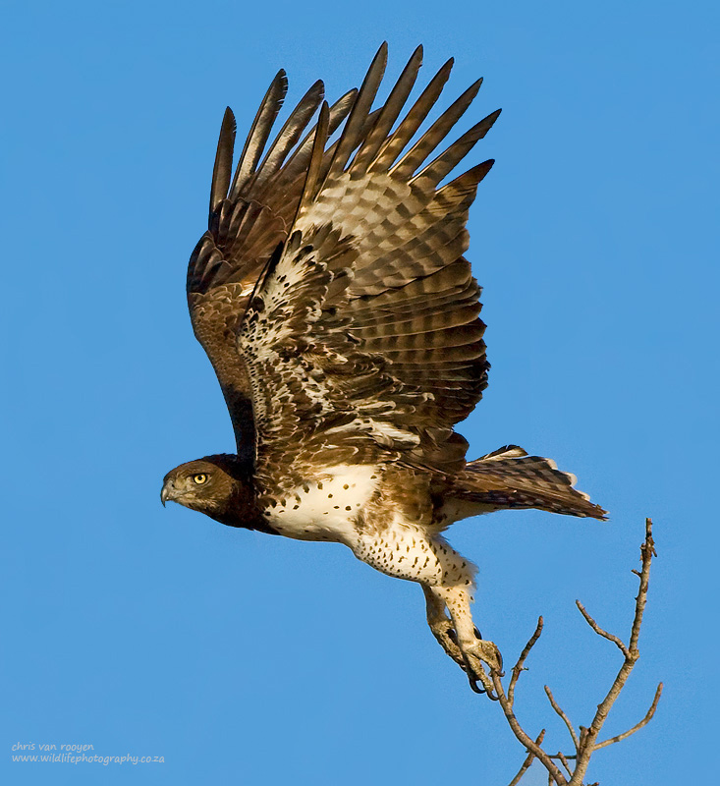

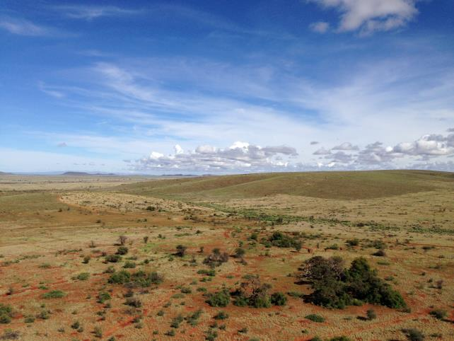

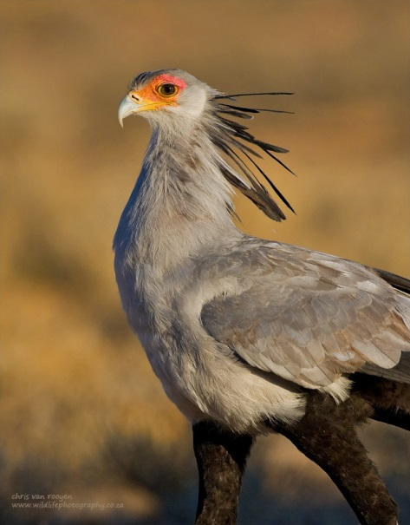

FEBRUARY 2015

Chris van Rooyen
Albert Froneman

Chris van Rooyen
Chris has seventeen years’ experience in the management of wildlife interactions with electricity infrastructure. He was head of the Eskom-Endangered Wildlife Trust (EWT) Strategic Partnership from 1996 to 2007, which has received international acclaim as a model of co-operative management between industry and natural resource conservation. He is an acknowledged global expert in this field and has worked in South Africa, Namibia, Botswana, Lesotho, New Zealand, Texas, New Mexico and Florida. Chris also has extensive project management experience and has received several management awards from Eskom for his work in the Eskom-EWT Strategic Partnership. He is the author of 15 academic papers (some with co-authors), co-author of two book chapters and several research reports. He has been involved as ornithological consultant in more than 100 power line and 25 wind generation projects. Chris is also co-author of the Best Practice for Avian Monitoring and Impact Mitigation at Wind Development Sites in Southern Africa, which is currently (2013) accepted as the industry standard. Chris also works outside the electricity industry and had done a wide range of bird impact assessment studies associated with various residential and industrial developments.

Albert Froneman (Pr.Sci.Nat)
Albert has an M. Sc. in Conservation Biology from the University of Cape Town, and started his career in the natural sciences as a Geographic Information Systems (GIS) specialist at Council for Scientific and Industrial Research (CSIR). He is a registered Professional Natural Scientist in the field of zoological science with the South African Council of Natural Scientific Professionals (SACNASP). In 1998, he joined the Endangered Wildlife Trust where he headed up the Airports Company South Africa – EWT Strategic Partnership, a position he held until he resigned in 2008 to work as a private ornithological consultant. Albert’s specialist field is the management of wildlife, especially bird related hazards at airports. His expertise is recognized internationally; in 2005 he was elected as Vice Chairman of the International Bird Strike Committee. Since 2010, Albert has worked closely with Chris van Rooyen in developing a protocol for pre-construction monitoring at wind energy facilities, and they are currently jointly coordinating pre-construction monitoring programmes at several wind farm facilities. Albert also works outside the electricity industry and had done a wide range of bird impact assessment studies associated with various residential and industrial developments.

DECLARATION OF INDEPENDENCE
I, Chris van Rooyen as duly authorised representative of Chris van Rooyen Consulting, and working under the supervision of and in association with Albert Froneman (SACNASP Zoological Science Registration number 400177/09) as stipulated by the Natural Scientific Professions Act 27 of 2003, hereby confirm my independence (as well as that of Chris van Rooyen Consulting) as a specialist and declare that neither I nor Chris van Rooyen Consulting have any interest, be it business, financial, personal or other, in any proposed activity, application or appeal in respect of which Landscape Dynamics Environmental Consulting was appointed as environmental assessment practitioner in terms of the National Environmental Management Act, 1998 (Act No. 107 of 1998), other than fair remuneration for worked performed, specifically in connection with the Environmental Impact Assessment for the proposed Manganore – Ferrum transmission line.
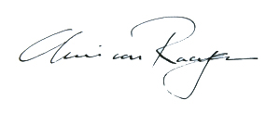
___________________________
Full Name: Chris van Rooyen
Title / Position: Director

EXECUTIVE SUMMARY

BACKGROUND
ESKOM has appointed Landscape Dynamics Environmental Consultants to undertake an Environmental Impact Assessment (EIA) for the proposed Kimberley Strengthening Phase 4 Project. The total project entails the construction of an approximate 390km double circuit 400kV power line. The line starts west of the town of Dealesville in the Free State and ends south of Kathu in the Northern Cape. The approximately 390km powerline runs east to west, starting at the Beta Substation, connects to the Boundary Substation, then on to the Ulco Substation, connects at the Olien Substation, then Manganore Substation and ends at the Ferrum Substation.

The project will be handled in four different applications:

- Application 1: Beta to Boundary (DEA Reference – 14/12/16/3/3/2/647)
- Application 2: Boundary to Ulco (DEA Reference – 14/12/16/3/3/2/646
- Application 3: Ulco to Olien to Manganore (DEA Reference – 14/12/16/3/3/2/645)
- Application 4: Manganore to Ferrum (DEA Reference – 14/12/16/3/3/2/644)

Landscape Dynamics Environmental Consultants has appointed Chris van Rooyen Consulting as specialist to investigate the potential bird related impacts associated with the proposed new transmission lines. This assessment report deals with Application 4 i.e. the construction of an approximately 67km double circuit 400kV powerline from the Manganore Substation to the Ferrum Substation, including the construction of the new Manganore TX (Transmission) Substation adjacent to the existing Manganore DX (Distribution) Substation. The line starts north of Postmasburg and runs in a northerly direction through areas of the Tsantsabane, Ga-Segonyana and Gamagara Local Municipalities and ends south of Kathu in the Northern Cape Province.

ELECTROCUTION
Electrocution refers to the scenario where a bird is perched or attempts to perch on the electrical structure and causes an electrical short circuit by physically bridging the air gap between live components and/or live and earthed components (van Rooyen 2004). The electrocution risk is largely determined by the pole/tower design. Potential tower types that could be utilised for the 400kV line are self-supporting towers, cross-rope suspension towers and guyed-V towers. The topography will largely dictate the type of tower that will be used. Due to the large size of the clearances on overhead lines of 400kV, electrocutions are ruled out as even the largest birds cannot physically bridge the gap between energised and/or energised and earthed components. In summary it can be stated that the risk of electrocution posed to Red Data species by the new power line infrastructure is likely to be negligible.

COLLISION
The most likely potential candidates for collision mortality on the proposed power line are Kori Bustard, Greater Flamingo, Lesser Flamingo, Secretarybird, Abdim’s Stork, White-backed Vulture, Black Stork, Verreaux’s Eagle and Martial Eagle. Ludwig’s Bustard will also be at risk, based on the species flight characteristics and tendency to fly long distances between foraging and roosting areas and when migrating. Movements by this species are triggered by rainfall (Allan 1994), and so are inherently erratic and unpredictable in this arid environment, where the quantity and timing of rains are highly variable between years. The highest risk for Ludwig’s Bustard is likely to be at dry riverbeds and dry pans. Flamingos and Maccoa Ducks might be at risk near water bodies, particularly pans when flooded. Kori Bustards might be at risk anywhere in the savanna habitat, particularly when flying to roost sites in the late afternoon and early evening. Secretarybirds will be most at risk in areas of open woodland with a prominent grass layer, and when descending to pans to drink, and in dry riverbeds and dry pans. Abdim’s Stork will be at risk at flooded pans, where they often roost in large numbers, in agricultural areas, and in river floodplains and dry pans. White-backed Vultures are at risk when descending to waterbodies to drink and bath or to carcasses. Black Stork will be at risk in river beds and pans. Black Stork, Lanner Falcon and Verreaux’s Eagle will be most at risk where the proposed lines skirt ridges and inselbergs. Tawny Eagle and Martial Eagle might be at risk anywhere in savanna habitat, but particularly when descending to and leaving from pans when visiting to drink and bath. Burchell’s Courser, Lanner Falcon and Double-banded Courser are also potentially at risk of collisions, but less so than the larger species as they are more agile and therefore less likely to collide with the earthwires of the proposed lines. The coursers are also not likely to regularly fly at power line heights.

DISTURBANCE AND HABITAT DESTRUCTION
In the present instance, the risk of displacement of Red Data species due to habitat destruction is likely to be fairly limited, given the nature of the habitat. Apart from direct habitat destruction, the above mentioned construction and maintenance activities also impact on birds through disturbance; this could lead to breeding failure if the disturbance happens during a critical part of the breeding cycle. Construction activities in close proximity could be a source of disturbance and could lead to temporary breeding failure or even permanent abandonment of nests. This is a particular concern where the proposed line is situated next to an existing transmission line which contains active raptor nests, e.g. Martial Eagle, Verreaux’s Eagle or Tawny Eagle.

PREFERRED ALTERNATIVE
Both the route alternative corridors emerged with very similar risk ratings, with only a 2% difference in ratings between the highest risk (Alternative One Route Corridor) and the lowest risk (Alternative Two Route Corridor). This indicates that both route alternative corridors are very similar as far as envisaged impacts on avifauna are concerned. Both corridors are therefore regarded as potentially suitable from an avifaunal impact perspective, with appropriate mitigation.

MITIGATION
It is not the objective of this report to attempt to demarcate all sections of power line for both the alternative corridors that would need to be mitigated for potential collisions or disturbance of Red Data breeding species. This can only be done once the final alignments have been selected and tower positions have been finalized. At this stage, the following recommendations are put forward from a potential bird impact perspective:

- For the reasons stated, both alternative route corridors are deemed suitable options from a bird impact assessment perspective.
- Once the final alignment and tower positions have been selected, the sections of the line that would need the application of Bird Flight Diverters to mitigate for potential collisions should be indicated by the avifaunal specialist by means of a “walk-through” exercise. This exercise should be informed by an analysis of satellite imagery supplemented by on site ground-truthing (physical inspection). The type of Bird Flight Diverter to be used and the marking scheme will be determined during that phase of the project.
- The Eskom standard procedure with regard to the clearing of vegetation must be strictly adhered to, to minimise the extent of habitat destruction during the construction phase. Existing roads should be used as far as possible to prevent further habitat fragmentation through the construction of new access roads, and to limit the construction footprint.
The existing lattice structure HV line must be inspected on foot by a suitably experienced ornithologist prior to construction to ascertain if any raptor nests are present. All relevant detail must be recorded i.e. species, structure number, coordinates and nest status. Should any nests be recorded, it would require management of the potential impacts on the breeding birds once construction commences, which would necessitate cooperation between the ornithologist and the Environmental Control Officer. An effective communication strategy should be implemented whereby the ornithologist is provided with a construction schedule which will enable him/her to ascertain when and where such breeding Red Data species could be impacted by the construction activities. This could then be addressed through the timing of construction activities during critical periods of the breeding cycle, once it has been established that a particular nest is active.

Introduction

ESKOM has appointed Landscape Dynamics Environmental Consultants to undertake an Environmental Impact Assessment (EIA) for the proposed Kimberley Strengthening Phase 4 Project. The total project entails the construction of an approximate 390km double circuit 400kV power line. The line starts west of the town of Dealesville in the Free State and ends south of Kathu in the Northern Cape. The approximately 390km powerline runs east to west, starting at the Beta Substation, connects to the Boundary Substation, then on to the Ulco Substation, connects at the Olien Substation, then Manganore Substation and ends at the Ferrum Substation.

The project will be handled in four different applications:

- Application 1: Beta to Boundary (DEA Reference – 14/12/16/3/3/2/647)
- Application 2: Boundary to Ulco (DEA Reference – 14/12/16/3/3/2/646
- Application 3: Ulco to Olien to Manganore (DEA Reference – 14/12/16/3/3/2/645)
- Application 4: Manganore to Ferrum (DEA Reference – 14/12/16/3/3/2/644)

Landscape Dynamics Environmental Consultants has appointed Chris van Rooyen Consulting as specialist to investigate the potential bird related impacts associated with the proposed new transmission lines. This assessment report deals with Application 4 i.e. the construction of an approximately 67km double circuit 400kV powerline from the Manganore Substation to the Ferrum Substation, including the construction of the new Manganore TX (Transmission) Substation adjacent to the existing Manganore DX (Distribution) Substation. The line starts north of Postmasburg and runs in a northerly direction through areas of the Tsantsabane, Ga-Segonyana and Gamagara Local Municipalities and ends south of Kathu in the Northern Cape Province.

See Figure 1 for a map of the various Manganore - Ferrum corridor alternatives.

Background and brief

The terms of reference for this impact assessment study are as follows:

- Describe the affected environment;
- Indicate how birdlife will be affected;
- Discuss gaps in baseline data;
- Evaluate the expected impacts;
- Indicate a preferred corridor; and
- Provide recommendations for mitigation.

Study Approach

3.1 Sources of information

The study made use of the following data sources:
- Bird distribution data of the Southern African Bird Atlas Project2 (SABAP2) was obtained (http://sabap2.adu.org.za/), in order to ascertain which species occur in the study area. A separate data set was obtained for each quarter degree grid cell (QDGC) which overlapped with the proposed corridors as well as the adjoining three QDGCs to the west, in order to get a more representative sample of the avifauna in these habitat types. QDGCs are grid cells that cover 15 minutes of latitude by 15 minutes of longitude (15” × 15”), which correspond to the area shown on a 1:50 000 map. The SABAP2 data covers the period 2007 to present. The QDGCs are 2823AA, 2723CC, 2723CA, 2722DB, 2722DD and 2822BB.
- The Important Bird Areas project was consulted to get an overview of important bird areas (IBAs) in the study area (Barnes 1998).
- The power line bird mortality incident database of the Endangered Wildlife Trust (1996 to 2007) was consulted to determine which of the species occurring in the study area are typically impacted upon by power lines (Jenkins et al. 2010).
- Land cover data for the study area was obtained from the National land Cover Project (NLCP) (updated version 2009), obtained from the South African National Biodiversity Institute.
- Areas of agricultural and industrial activity were demarcated from Google Earth imagery to augment the above landcover data.
- Data on biomes and vegetation types in the study area was obtained from the Vegetation Map of South Africa, (Mucina & Rutherford 2006) and Vegetation of South Africa, Lesotho and Swaziland (Low & Rebelo 1996).
- The conservation status of all species considered likely to occur in the area was determined as per the most recent iteration of the South African Red Data list for birds (Taylor 2014), and the most recent and comprehensive summary of southern African bird biology (Hockey et al. 2005).
- Personal observations have also been used to supplement the data that is available from SABAP, and has been used extensively in forming a professional opinion of likely bird/habitat associations.
- Onsite inspections in a vehicle and on foot, and a helicopter fly-over, were conducted during February 2014 to gain a general impression of bird habitats.

3.2 Limitations & assumptions

This study made the assumption that the above sources of information are reliable. However, the following factors may potentially detract from the accuracy of the predicted results:

- Although the NLCP data was updated in 2009, the land cover situation on the ground may have changed in places since then.
- Different levels of survey effort for pentads in the SABAP2 coverage means that the reporting rates of species may not be an accurate reflection of relative densities in the pentads that were sparsely covered to date, and which makes up the relevant QDGCs (one QDGC encompasses 9 pentads). The reporting rates were therefore not treated as an absolute measurement of the actual densities, but as an estimate for the potential presence of a specific species. Strong reliance was placed on professional judgment (see 3.1 above).
- Predictions in this study are based on experience of these and similar species in different parts of South Africa. Bird behaviour can never be entirely reduced to formulas that will hold true under all circumstances; therefore professional judgment played an important role in this assessment. It should also be noted that the impact of power lines on birds has been well researched with a robust body of published research stretching over thirty years.

Study area

4.1 Important Bird Areas

The study area extends for approximately 67km from the Manganore Substation approximately 20km north of Postmasburg to the Ferrum Substation approximately 4km south of Kathu. There are two alternative corridors. Investigations are focused on a 2km wide corridor with the proposed alignment as the centre line (see Figure 1 below). There are no Important Bird Areas (IBAs) located close to the study area, the closest IBA, SA028 (Spitskop Dam) (Barnes 1998), is located approximately 140km east of the proposed line.
SA023

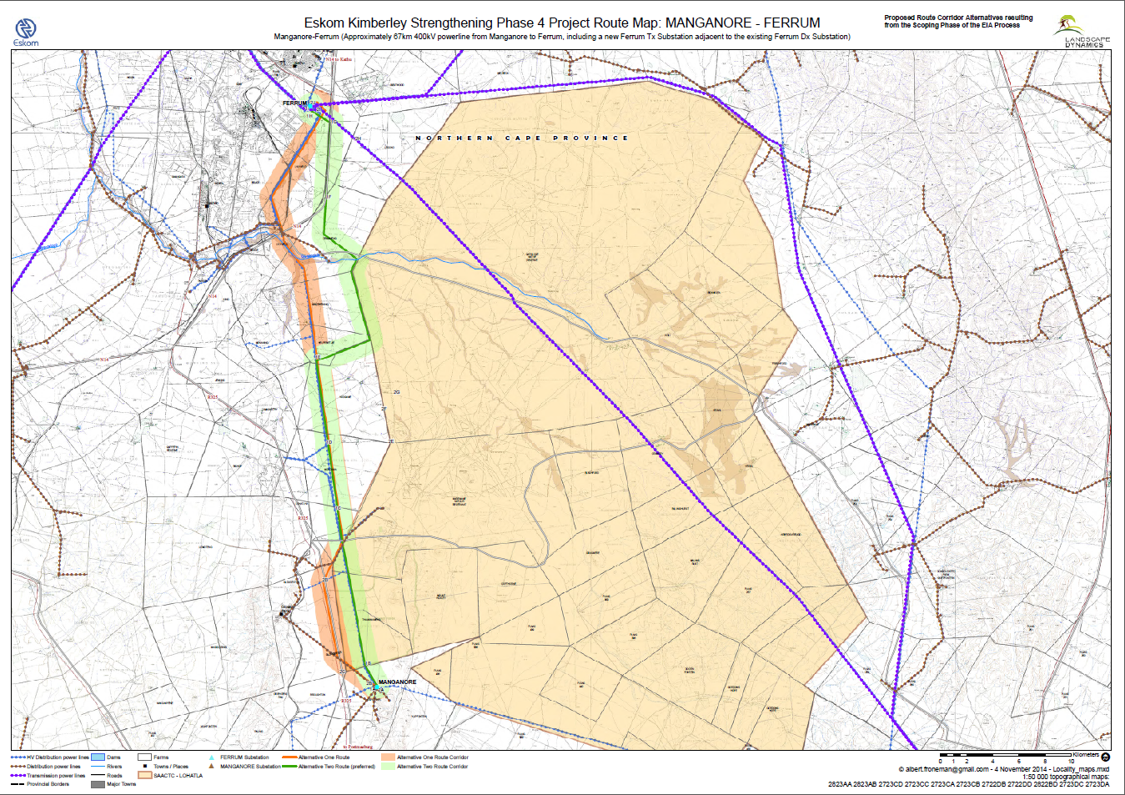
Figure 1: Map of the two proposed corridor alternatives for the Manganore - Ferrum 400kV line
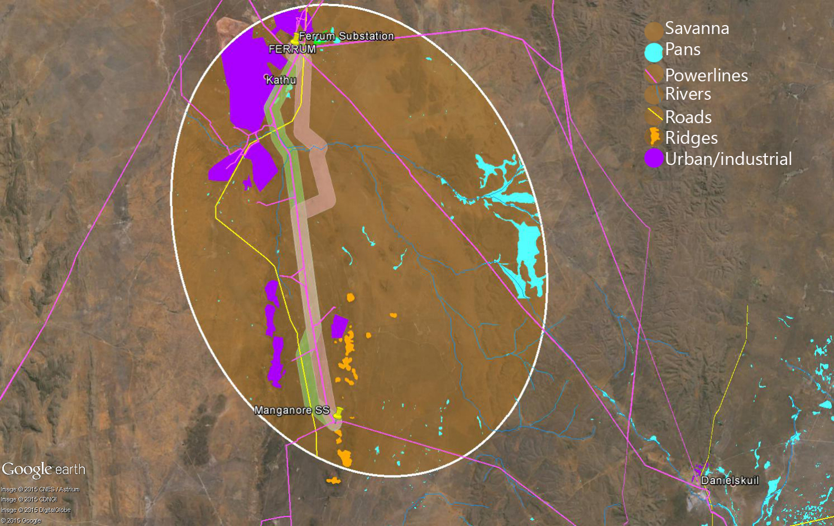
Figure 2: Satellite map of the two proposed corridor alternatives for the Manganore - Ferrum 400kV line

4.2 Primary vegetation divisions (biomes)

The study area extends over a single primary vegetation division, namely savanna (woodland) (Mucina & Rutherford 2006) (see Figure 3). It is generally accepted that vegetation structure, rather than the actual plant species, influences bird species distribution and abundance (Harrison et al. 1997). From an avifaunal perspective, the Atlas of southern African Birds (SABAP1) recognises six primary vegetation divisions or biomes within South Africa, namely (1) Fynbos (2) Succulent Karoo (3) Nama Karoo (4) Grassland (5) Savanna and (6) Forest (Harrison et al. 1997). These vegetation descriptions do not focus on lists of plant species, but rather on factors which are relevant to bird distribution. The criteria used by the SABAP1 authors to amalgamate botanically defined vegetation units, or to keep them separate were (1) the existence of clear differences in vegetation structure, likely to be relevant to birds, and (2) the results of published community studies on bird/vegetation associations.

4.3 Description of bird habitat classes

Whilst much of the distribution and abundance of the bird species in the study area can be explained by the composition of the natural vegetation, it is as important to also examine the modifications which have changed the natural landscape, and which may have an effect on the distribution of power line sensitive species. These are sometimes evident at a much smaller spatial scale than the biome types, and are determined by a host of factors such as vegetation type, topography, land use and man-made infrastructure. For purposes of the analysis in this report, the following bird habitat classes were defined from an avifaunal Red Data power line sensitive perspective (vegetation descriptions based largely on Harrison et al. 1997; Mucina & Rutherford 2006; Low & Robelo 1996):

4.3.1 Savanna

The study area is situated in savanna, consisting primarily of a mixture of Kuruman Mountain Bushveld, Kuruman Thornveld and Kathu Bushveld (mainly around Ferrum Substation). Kuruman Mountain Bushveld occurs on ridges and inselbergs and consists of open shrubveld with Lebeckia macrantha prominent in places, and a well-developed grass layer. Rainfall (250 – 500mm) is in summer and autumn with very dry winters. Kuruman Thornveld occurs on flat, rocky plains and some sloping hills with very well-developed, closed shrub layer and well-developed open tree stratum consisting of Acacia eriobola. Rainfall (300 – 450mm) is in summer and autumn with very dry winters, with temperatures ranging from -3.3°C to 36°C. Kathu Bushveld consists of a medium tall tree layer with Acacia erioloba in places but mostly open and including Boscia albitrunca as the prominent trees. Shrub layer is very well developed and grass layer is variable. Rainfall (220 – 380mm) is in summer and autumn with very dry winters.

The power line sensitive Red Data avifauna occurring in this habitat is typically arid woodland species i.e. White-backed Vulture, Tawny Eagle, Martial Eagle, Lanner Falcon, Verreaux’s Eagle (ridges and koppies), Secretarybird and Kori Bustard.

4.3. 2 Pans

A feature of the arid landscape where the proposed power line is located is the presence of pans, a few of which occur in the central and eastern part of the study area (the latter being associated with floodplains) (see Figure 2). Pans are endorheic wetlands having closed drainage systems; water usually flows in from small catchments but with no outflow from the pan basins themselves. They are characteristic of poorly drained, relatively flat and dry regions. Water loss is mainly through evaporation, sometimes resulting in saline conditions, especially in the most arid regions. When flooded, the water depth is shallow (<3m), and flooding characteristically ephemeral (Harrison et al. 1997). When flooded, pans are important for a variety of power line sensitive Red Data species which potentially occur in the study area e.g. Black Stork, Greater Flamingo, Lesser Flamingo, Abdim’s Stork and Maccoa Duck. Flooded pans are also used by raptors and vultures for drinking and bathing. When dry, the pans are usually covered in short grass often dominated by Sporobolus species, with a mixture of dwarf shrubs (Mucina & Rutherford 2006). Species that may seek out dry pans are Double-banded Courser, Burchell’s Courser, Ludwig’s Bustard, Kori Bustard and Secretarybird. There are no large pans near the proposed corridors, but a few small pans are present in the central part of the study area.

4.3.3 Rivers

The study area contains no perennial rivers, but it does contain several ephemeral drainage lines, the largest being the Ga-Mogara River with several tributaries, which crosses the study area from east to west. After rains, when large pools form in the ephemeral river channels, they are important for a variety of waterbirds, including Red Data Black Stork, while Abdim’s Stork are attracted to the grass-covered river channels and adjacent floodplain areas. The grassy river channels are also attractive to Ludwig’s Bustards and Secretarybirds.

4.3.5 Agricultural lands

The study area contains a few agricultural lands in the extreme north of the study area near Ferrum Substation. Although agricultural lands completely destroy the structure of the original vegetation, some birds do benefit from this transformation. Abdim’s Stork and Ludwig’s Bustard (to a lesser extent) are the Red Data species most likely to utilise agricultural lands in the study area.

4.3.6 Cliffs and ridges

In places the proposed alignments run between rocky ridges and inselbergs which offer potentially suitable roosting and breeding habitat for a number of Red Data power line sensitive species, e.g. Black Stork, Lanner Falcon, and Verreaux’s Eagle. In the south of the study area, near Manganore Substation, the Klipfontein Hills and a couple of isolated inselbergs provide suitable habitat for the aforementioned species.

4.3.7 Transmission lines

Transmission lines are an important roosting and breeding substrate for large raptors in the study area. Existing transmission lines are used extensively by large raptors e.g. in 2005 the author did an aerial survey of the Ferrum – Garona 275kV line together with Eskom, and found a total of 19 Martial Eagle and 7 Tawny Eagle nests on transmission line towers (Van Rooyen 2007). Lanner Falcon also breeds regularly in crow nests on transmission lines, and White-backed Vultures may use them as perches and roosts in the study area. Transmission lines therefore hold a special importance for raptors in the study area.

4.2 Power line sensitive species potentially occurring in the study area

A total of 15 Red Data species could potentially occur in the study area (see Table 1). For each species, the potential for occurring in a specific habitat class was indicated, as well as the potential impact most likely associated with this specific species.

Table 1: Red Data species potentially occurring in the study area.

NT=Near threatened VU=Vulnerable EN = Endangered

Name | Scientific name | Conservation status (Taylor, 2014) | Rivers | Cliffs & ridges | Savanna | Pans | Agricultural lands | TX lines | Collisions | Displacement through disturbance | Displacement through habitat destruction
Kori Bustard | Ardeatis kori | NT | x | - | x | x | x | - | x | - | -
Lanner Falcon | Falco biarmicus | VU | - | x | x | x | x | x | x | x | -
Ludwig's Bustard | Neotos ludwigii | EN | x | - | x | x | x | - | x | - | -
Martial Eagle | Polemaetus bellicosus | EN | - | - | x | x | - | x | x | x | -
Abdim’s Stork | Ciconia abdimii | NT | x | - | - | x | x | - | x | - | -
Burchell’s Courser | Cursorius rufus | VU | - | - | - | x | x | - | x | - | -
Verreaux's Eagle | Aquila verreauxii | VU | - | x | - | - | - | x | x | x | -
White-backed Vulture | Gyps africanus | VU | - | - | x | x | - | x | x | - | -
Black Stork | Ciconia nigra | VU | x | x | - | x | - | - | x | x | -

Name | Scientific name | Conservation status (Taylor, 2014) | Rivers | Cliffs & ridges | Savanna | Pans | Agricultural lands | TX lines | Collisions | Displacement through disturbance | Displacement through habitat destruction
Secretarybird | Sagittarius serpentarius | VU | x | - | x | x | - | - | x | - | -
Tawny Eagle | Aquila rapax | EN | - | - | x | x | - | x | x | x | -
Lesser Flamingo | Phoenicopterus minor | NT | - | - | - | x | - | - | x | - | -
Greater Flamingo | Phoenicopterus roseus | NT | - | - | - | x | - | - | x | - | -
Double-banded Courser | Rhinoptilus africanus | NT | - | - | - | x | - | - | x | - | -
Maccoa Duck | Oxyura maccoa | NT | x | - | - | x | - | - | x | - | -

Description of expected impacts

Because of their size and prominence, electrical infrastructures constitute an important interface between wildlife and man. Negative interactions between wildlife and electricity structures take many forms, but two common problems in southern Africa are electrocution of birds (and other animals) and birds colliding with power lines. (Ledger and Annegarn 1981; Ledger 1983; Ledger 1984; Hobbs and Ledger 1986a; Hobbs and Ledger 1986b; Ledger, Hobbs and Smith, 1992; Verdoorn 1996; Kruger and Van Rooyen 1998; Van Rooyen 1998; Kruger 1999; Van Rooyen 1999; Van Rooyen 2000; Anderson 2001; Shaw 2013).

5.1 Electrocutions

Electrocution refers to the scenario where a bird is perched or attempts to perch on the electrical structure and causes an electrical short circuit by physically bridging the air gap between live components and/or live and earthed components (van Rooyen 2004). The electrocution risk is largely determined by the pole/tower design. Potential tower types that could be utilised for the 400kV line are self-supporting towers, cross-rope suspension towers and guyed-V towers. The topography will largely dictate the type of tower that will be used. Due to the large size of the clearances on overhead lines of 400kV, electrocutions are ruled out as even the largest birds cannot physically bridge the gap between energised and/or energised and earthed components. In summary it can be stated that the risk of electrocution posed to Red Data species by the new power line infrastructure is likely to be negligible.

5.2 Collisions

Collisions are probably the biggest single threat posed by transmission lines to birds in southern Africa (van Rooyen 2004; Shaw 2013). Most heavily impacted upon are bustards, storks, cranes and various species of waterbirds. These species are mostly heavy-bodied birds with limited manoeuvrability, which makes it difficult for them to take the necessary evasive action to avoid colliding with power lines (van Rooyen 2004; Anderson 2001; Shaw 2013).

In a recent PhD study, Shaw (2013) provides a concise summary of the phenomenon of avian collisions with power lines:

“The collision risk posed by power lines is complex and problems are often localised. While any bird flying near a power line is at risk of collision, this risk varies greatly between different groups of birds, and depends on the interplay of a wide range of factors (APLIC 1994). Bevanger (1994) described these factors in four main groups – biological, topographical, meteorological and technical. Birds at highest risk are those that are both susceptible to collisions and frequently exposed to power lines, with waterbirds, gamebirds, rails, cranes and bustards usually the most numerous reported victims (Bevanger 1998, Rubolini et al. 2005, Jenkins et al. 2010).

The proliferation of man-made structures in the landscape is relatively recent, and birds are not evolved to avoid them. Body size and morphology are key predictive factors of collision risk, with large-bodied birds with high wing loadings (the ratio of body weight to wing area) most at risk (Bevanger 1998, Janss 2000). These birds must fly fast to remain airborne, and do not have sufficient manoeuvrability to avoid unexpected obstacles. Vision is another key biological factor, with many collision-prone birds principally using lateral vision to navigate in flight, when it is the lower-resolution, and often restricted, forward vision that is useful to detect obstacles (Martin & Shaw 2010, Martin 2011, Martin et al. 2012). Behaviour is important, with birds flying in flocks, at low levels and in crepuscular or nocturnal conditions at higher risk of collision (Bevanger 1994). Experience affects risk, with migratory and nomadic species that spend much of their time in unfamiliar locations also expected to collide more often (Anderson 1978, Anderson 2002). Juvenile birds have often been reported as being more collision-prone than adults (e.g. Brown et al. 1987, Henderson et al. 1996).

Topography and weather conditions affect how birds use the landscape. Power lines in sensitive bird areas (e.g. those that separate feeding and roosting areas, or cross flyways) can be very dangerous (APLIC 1994, Bevanger 1994). Lines crossing the prevailing wind conditions can pose a problem for large birds that use the wind to aid take-off and landing (Bevanger 1994). Inclement weather can disorient birds and reduce their flight altitude, and strong winds can result in birds colliding with power lines that they can see but do not have enough flight control to avoid (Brown et al. 1987, APLIC 1994).

The technical aspects of power line design and siting also play a big part in collision risk. Grouping similar power lines on a common servitude, or locating them along other features such as tree lines, are both approaches thought to reduce risk (Bevanger 1994). In general, low lines with short span lengths (i.e. the distance between two adjacent pylons) and flat conductor configurations are thought to be the least dangerous (Bevanger 1994, Jenkins et al. 2010). On many higher voltage lines, there is a thin earth (or ground) wire above the conductors, protecting the system from lightning strikes. Earth wires are widely accepted to cause the majority of collisions on power lines with this configuration because they are difficult to see, and birds flaring to avoid hitting the conductors often put themselves directly in the path of these wires (Brown et al. 1987, Faanes 1987, Alonso et al. 1994a, Bevanger 1994).”

As mentioned by Shaw (2013) in the extract above, several factors are thought to influence avian collisions, including the manoeuvrability of the bird, topography, weather conditions and power line configuration. An important additional factor that previously has received little attention is the visual capacity of birds; i.e. whether they are able to see obstacles such as power lines, and whether they are they looking ahead to see obstacles with enough time to avoid a collision. In addition to helping explain the susceptibility of some species to collision, this factor is key to planning effective mitigation measures. Recent research provides the first evidence that birds can render themselves blind in the direction of travel during flight through voluntary head movements (Martin & Shaw 2010). Visual fields were determined in three bird species representative of families known to be subject to high levels of mortality associated with power lines i.e. Kori Bustards, Blue Cranes and White Storks Ciconia ciconia. In all species the frontal visual fields showed narrow and vertically long binocular fields typical of birds that take food items directly in the bill under visual guidance. However, these species differed markedly in the vertical extent of their binocular fields and in the extent of the blind areas which project above and below the binocular fields in the forward facing hemisphere. The importance of these blind areas is that when in flight, head movements in the vertical plane (pitching the head to look downwards) will render the bird blind in the direction of travel. Such movements may frequently occur when birds are scanning below them (for foraging or roost sites, or for conspecifics). In bustards and cranes pitch movements of only 25° and 35° respectively are sufficient to render the birds blind in the direction of travel; in storks head movements of 55° are necessary. That flying birds can render themselves blind in the direction of travel has not been previously recognised and has important implications for the effective mitigation of collisions with human artefacts including wind turbines and power lines. These findings have applicability to species outside of these families especially raptors (Accipitridae) which are known to have small binocular fields and large blind areas similar to those of bustards and cranes, and are also known to be vulnerable to power line collisions.

Thus visual field topographies which have evolved primarily to meet visual challenges associated with foraging may render certain bird species particularly vulnerable to collisions with human artefacts, such as power lines and wind turbines that extend into the otherwise open airspace above their preferred habitats. For these species placing devices upon power lines to render them more visible may have limited success since no matter what the device the birds may not see them. It may be that in certain situations it may be necessary to distract birds away from the obstacles, or encourage them to land nearby (for example by the use of decoy models of conspecifics, or the provision of sites attractive for roosting) since increased marking of the obstacle cannot be guaranteed to render it visible if the visual field configuration prevents it being detected. Perhaps most importantly, the results indicate that collision mitigation may need to vary substantially for different collision prone species, taking account of species specific behaviours, habitat and foraging preferences, since an effective all-purpose marking device is probably not realistic if some birds do not see the obstacle at all (Martin & Shaw 2010).
A significant impact that is foreseen for the proposed Manganore - Ferrum transmission line is collisions with the earth wire of the proposed line. Quantifying this impact in terms of the likely number of birds that will be impacted, is very difficult because such a huge number of variables play a role in determining the risk, for example weather, rainfall, wind, age, flocking behaviour, power line height, light conditions, topography, population density and so forth. However, from incidental record keeping by the Endangered Wildlife Trust, it is possible to give a measure of what species are likely to be impacted upon (see Figure 3 below - Jenkins et al. 2010). This only gives a measure of the general susceptibility of the species to power line collisions, and not an absolute measurement for any specific line.

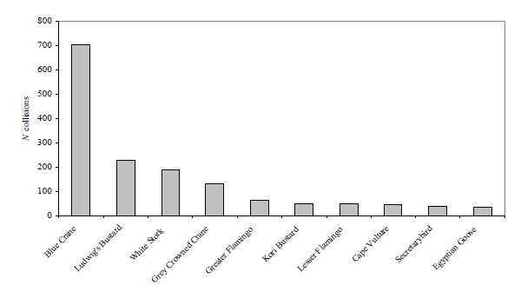
Figure 3: The top 10 collision prone bird species in South Africa, in terms of reported incidents contained in the Eskom/EWT Strategic Partnership central incident register 1996 - 2008 (Jenkins et al. 2010)

The most likely potential candidates for collision mortality on the proposed power line are Kori Bustard, Greater Flamingo, Lesser Flamingo, Secretarybird, Abdim’s Stork, White-backed Vulture, Black Stork, Verreaux’s Eagle and Martial Eagle. Ludwig’s Bustard will also be at risk, based on the species flight characteristics and tendency to fly long distances between foraging and roosting areas and when migrating. Movements by this species are triggered by rainfall (Allan 1994), and so are inherently erratic and unpredictable in this arid environment, where the quantity and timing of rains are highly variable between years. The highest risk for Ludwig’s Bustard is likely to be at dry riverbeds and dry pans. Flamingos and Maccoa Ducks might be at risk near water bodies, particularly pans when flooded. Kori Bustards might be at risk anywhere in the savanna habitat, particularly when flying to roost sites in the late afternoon and early evening. Secretarybirds will be most at risk in areas of open woodland with a prominent grass layer, and when descending to pans to drink, and in dry riverbeds and dry pans. Abdim’s Stork will be at risk at flooded pans, where they often roost in large numbers, in agricultural areas, and in river floodplains and dry pans. White-backed Vultures are at risk when descending to waterbodies to drink and bath or to carcasses. Black Stork will be at risk in river beds and pans. Black Stork, Lanner Falcon and Verreaux’s Eagle will be most at risk where the proposed lines skirt ridges and inselbergs. Tawny Eagle and Martial Eagle might be at risk anywhere in savanna habitat, but particularly when descending to and leaving from pans when visiting to drink and bath. Burchell’s Courser, Lanner Falcon and Double-banded Courser are also potentially at risk of collisions, but less so than the larger species as they are more agile and therefore less likely to collide with the earthwires of the proposed lines. The coursers are also not likely to regularly fly at power line heights.

5.3 Displacement due to habitat destruction and disturbance

During the construction phase and maintenance of power lines and substations, some habitat destruction and transformation inevitably takes place. This happens with the construction of access roads, the clearing of servitudes and the levelling of substation yards. Servitudes have to be cleared of excess vegetation at regular intervals in order to allow access to the line for maintenance, to prevent vegetation from intruding into the legally prescribed clearance gap between the ground and the conductors and to minimize the risk of fire under the line, which can result in electrical flashovers. These activities have an impact on birds breeding, foraging and roosting in or in close proximity of the servitude through transformation of habitat, which could result in temporary or permanent displacement. In the present instance, the risk of displacement of Red Data species due to habitat destruction is likely to be fairly limited, given the nature of the habitat.

Apart from direct habitat destruction, the above mentioned construction and maintenance activities also impact on birds through disturbance; this could lead to breeding failure if the disturbance happens during a critical part of the breeding cycle. Construction activities in close proximity could be a source of disturbance and could lead to temporary breeding failure or even permanent abandonment of nests. This is a particular concern where the proposed line is situated next to an existing transmission line which contains active raptor nests, e.g. Martial Eagle, Verreaux’s Eagle or Tawny Eagle.

- Assessment of impacts and selection of a preferred alternative

One of the main objectives of this study is to arrive at a preferred corridor for the proposed transmission power lines, from an avifaunal interaction perspective. The methods that were followed to select a preferred corridor alternative are outlined below.

6.1 Methods

The potential for interaction with the proposed power line was assessed for each of the Red Data species recorded in the QDGCs which contain the study area, as well as the three adjacent QDGCs. This was done by assessing the probability of each potential impact (collisions, displacement through disturbance and displacement through habitat destruction) occurring, for each species, within each of the described habitat classes. The following probability scale was used: 1 = low, 2 = medium, 3 = high. Each habitat class therefore received a habitat score for each species. The habitat score was then multiplied with the national Red Data status of the species (Near Threatened = 1, Vulnerable = 2, Endangered = 3, Critically Endangered = 4) and the reporting rate for the species in the QDGC, to arrive at a risk score for each species for each habitat class (see Appendix 2). The total risk score for a habitat class was calculated as the sum of the various individual species risk scores for that habitat class.

Table 2 below gives the risk scores for each of the habitat classes:

Table 2: Risk scores for each habitat class
Habitat class | Score
Urban | 0
Powerlines | 5
Ridges | 28
Wetlands and waterbodies | 49
Rivers | 18
Agriculture | 9
Savanna | 12

The risk scores in Table 2 were incorporated into a formula to arrive at a risk rating for each 2km wide corridor alternative. The surface area of each habitat class within a corridor was calculated. The risk rating for a route alternative corridor was calculated by multiplying the percentage that each habitat class constitute of the total surface area of the 2km wide corridor with the risk score for that habitat class, and then adding up the totals. In the GIS analysis, a hierarchical exclusion system was used to compile an avifaunal habitat map. The different habitat classes were layered in the following sequence (starting from the bottom i.e. each consecutive layer would exclude its underlying layers): Biome, agriculture, rivers, pans, ridges, power lines, urban. The risk ratings of the respective route alternative corridors are listed in Table 3 below, and in Appendix 3.

Table 3: Risk rating for each alternative corridor
MANGANORE-FERRUM | Risk rating
Alt 1 | 13.31
Alt 2 | 13.63

Both the route alternative corridors emerged with very similar risk ratings, with only a 2% difference in ratings between the highest risk (Alternative One Route Corridor) and the lowest risk (Alternative Two Route Corridor). This indicates that both route alternative corridors are very similar as far as envisaged impacts on avifauna are concerned. Both corridors are therefore regarded as potentially suitable from an avifaunal impact perspective, with appropriate mitigation.

7 Assessment of impacts

The impact assessment methodology makes provision for the assessment of impacts against the following criteria:

- Extent of impact
- Duration of impact
- Probability of impact
- Magnitude/Intensity of impact
- Significance of impact

Extent of impact | Explanation of extent
Site | Impacts limited to construction site and direct surrounding area
Local | Impacts affecting environmental elements within the local area / district
Regional | Impacts affecting environmental elements within the province
National | Impacts affecting environmental elements on a national level
Global | Impacts affecting environmental elements on a global level

Duration of impact | Explanation of duration
Short term | 0 - 5 years. The impact is reversible in less than 5 years.
Medium term | 5 - 15 years. The impact is reversible in less than 15 years.
Long term | >15 years, but where the impacts will cease if the project is decommissioned
Permanent | The impact will continue indefinitely and is irreversible.

Probability of impact | Explanation of Probability
Unlikely | The chance of the impact occurring is extremely low
Possible | The impact may occur
Probable | The impact will very likely occur
Definite | Impact will certainly occur

Magnitude/Intensity of impact | Explanation of Magnitude/Intensity
Low | Where the impact affects the environment in such a way that natural, social and cultural functions and processes are not affected
Moderate | Where the affected environment is altered, but natural, social and cultural functions and processes continue albeit in a modified way
Severe | Where natural, social and cultural functions or processes are altered to the extent that it will temporarily or permanently cease

Significance of impact | Explanation of Significance
None | There is no impact at all
Low | Impact is negligible or is of a low order and is likely to have little real effect
Moderate | Impact is real but not substantial
High | Impact is substantial
Very high | Impact is very high and can therefore influence the viability of the project

Manganore Ferrum Alternative One Route Corridor
Impact Description | Extent  Site / Local /  Regional /  National / Global | Duration  Short / Medium / Long / Permanent | Probability  Unlikely / Possible / Probable / Definite | Magnitude / Intensity  Low / Moderate / Severe | Significance of Impact  without Mitigation  None, Low, Moderate, High, Very High | Significance of Impact  After Mitigation  None, Low, Moderate, High, Very High
Displacement of Red Data species through disturbance during the construction of the proposed transmission line | Site | Short term | Probable | Moderate | Moderate | Low
Displacement of Red Data species through habitat destruction due to the construction of the proposed transmission line | Site | Short term | Possible | Low | Low | Low
Mortality of Red Data species due to collisions with the earth wire of the proposed transmission line | Regional | Long term | Probable | Moderate | Moderate | Low
Manganore Ferrum Alternative Two Route Corridor
Impact Description | Extent  Site / Local /  Regional /  National / Global | Duration  Short / Medium / Long / Permanent | Probability  Unlikely / Possible / Probable / Definite | Magnitude / Intensity  Low / Moderate / Severe | Significance of Impact  without Mitigation  None, Low, Moderate, High, Very High | Significance of Impact  After Mitigation  None, Low, Moderate, High, Very High
Displacement of Red Data species through disturbance during the construction of the proposed transmission line | Site | Short term | Probable | Moderate | Moderate | Low
Displacement of Red Data species through habitat destruction due to the construction of the proposed transmission line | Site | Short term | Possible | Low | Low | Low
Mortality of Red Data species due to collisions with the earth wire of the proposed transmission line | Regional | Long term | Probable | Moderate | Moderate | Low

8 Mitigation

Any attempt at quantifying the potential bird impacts for the proposed development would entail the collection of significant amounts of quantitative data, for example one would have to establish how many pairs of a given species are using a particular area of woodland and document the potential breeding failure through disturbance that could occur if a transmission line is constructed through that area of woodland. Then the influence of this impact on the ability of the local, regional or even national population to persist would have to be documented and quantified. Clearly such detailed studies fall outside the scope of this report. The fact that impacts such as habitat destruction and disturbance could be significant but difficult to quantify, requires that all possible mitigation measures should be implemented on the basis of the pre-cautionary principle. The World Charter for Nature, which was adopted by the UN General Assembly in 1982, was the first international endorsement of the precautionary principle. The principle was implemented in an international treaty as early as the 1987 Montreal Protocol and among other international treaties and declarations is reflected in the 1992 Rio Declaration on Environment and Development. Principle 15 of the Rio Declaration 1992 states that: “in order to protect the environment, the precautionary approach shall be widely applied by States according to their capabilities. Where there are threats of serious or irreversible damage, lack of full scientific certainty shall be not used as a reason for postponing cost-effective measures to prevent environmental degradation.”.

There are many methods that can be used to mitigate avian power line interactions and several investigations dealing with the collision problem have focused on finding suitable mitigation measures (see for example APLIC 2012 and Shaw 2013). The most proactive measures are power line route planning (and the subsequent avoidance of areas with a high potential for bird strikes) and the modification of power line designs (this option includes line relocations, underground burial of lines, removal of over-head ground wires, and the marking of ground wires to make them more visible to birds in flight). In many instances, decisions on power line placement and possible mitigation measures are however eventually based on economic factors. The relocation of an existing line is the last option that is usually considered when trying to mitigate avian collisions. The huge expense of creating a new line and servitude usually cannot be justified unless there are biologically significant mortalities. Underground burial of power lines is another option available to utility companies in areas of high collision risk. This will obviously eliminate collisions, but the method has many drawbacks. The costs of burying lines can be from 20 – 30 times (or more) higher than constructing overhead lines, and such costs are related to the line voltage, type and length of cable, cable insulation, soil conditions, local regulations, reliability requirements, and requirement of termination areas. Limitations of cable burial include: no economically feasible methods of burying extra high voltage lines have been developed, there is a potential to contaminate underground water supplies if leakage of oil used in insulating the lines occurs, and extended outage risks due to the difficulty in locating cable failures (APLIC 2012). Since most strikes involve earth-wires (more than 80% of observed bird collisions), the removal of these wires would decrease the number of collisions. It is assumed that the large number of earth-wire collisions is because birds react to the more visible conductors by flaring and climbing and then collide with the thinner earth-wires (Anderson 2001). Earth-wire removal is, however, not a simple matter. Due to the need for lightning protection and other types of electricity overload, it is only possible on lower-voltage power lines (where polymer lightning arresters can be used). The marking of overhead earth-wires to increase their visibility is usually considered to be the most economical mitigation option for reducing collision mortality (APLIC 2012, Shaw 2013). This is particular so for the thousands of kilometres of established power lines through areas of high potential for avian interaction which cannot be rerouted.

Several factors are thought to influence avian collisions, including the manoeuvrability of the bird, topography, weather conditions and power line configuration. An important additional factor that previously has received little attention is the visual capacity of birds; i.e. whether they are able to see obstacles such as power lines, and whether they are they looking ahead to see obstacles with enough time to avoid a collision. In addition to helping explain the susceptibility of some species to collision, this factor is key to planning effective mitigation measures (Martin et al. 2010). Recent research conducted by Eskom and the Endangered Wildlife Trust provides the first evidence that birds can render themselves blind in the direction of travel during flight through voluntary head movements. Due to the variation in visual fields among species, there is unlikely to be a single solution for mitigating all collisions. Line marking alone is likely to be effective for storks, but for birds such as bustards, additional mitigation may be necessary, as these birds may not see obstacles at all when in flight. Distracting such birds away from obstacles or encouraging them to land nearby may help to prevent collisions, as they would be more aware of their surroundings and of marked power lines when taking off again (Martin et al. 2010). In certain situations birds such as bustards, cranes and raptors are unlikely to see ahead of them, no matter what mitigation measures are placed upon the actual obstacle. This is because the visual field configuration, coupled with possible head movements associated with searching below, prevents it being detected. For these species it may be better to distract birds away from, or encourage them to land nearby to power lines. Placing markers on the ground might have this effect. Bird silhouettes, painted drums or flags could prove effective, and it is recommended that such methods be used in combination with line marking. Unfortunately, no research is available on the effectiveness of ground marking.

However, despite doubts about the efficacy of line marking to reduce the collision risk for bustards (Jenkins et al. 2010; Martin et al. 2010), there are numerous studies which prove that marking a line with PVC spiral type Bird Flight Diverters (BFDs) generally reduce mortality rates (e.g. Barrientos et al. 2011; Jenkins et al. 2010; Alonso & Alonso 1999; Koops & De Jong 1982), even for bustards (Barrientos et al. 2012). Beaulaurier (1981) summarised the results of 17 studies that involved the marking of earth wires and found an average reduction in mortality of 45%. A Spanish study (Barrientos et al 2011) reviewed the results of 15 wire marking experiments in which transmission or distribution wires were marked to examine the effectiveness of flight diverters in reducing bird mortality. The presence of flight diverters was associated with a decrease in bird collisions. At unmarked lines, there were 0.21 deaths/1000 birds (n = 339,830) that flew among lines or over lines. At marked lines, the mortality rate was 78% lower (n = 1,060,746). Koops and De Jong (1982) found that the spacing of the BFDs were critical in reducing the mortality rates - mortality rates are reduced up to 86% with a spacing of 5 metres, whereas using the same devices at 10 metre intervals only reduces the mortality by 57%. Barrientos et al. (2012) found that larger BFDs were more effective in reducing Great Bustard collisions than smaller ones. Line markers should be as large as possible, and highly contrasting with the background. Colour is probably less important as during the day the background will be brighter than the obstacle with the reverse true at lower light levels (e.g. at twilight, or during overcast conditions). Black and white interspersed patterns are likely to maximise the probability of detection (Martin et al. 2010).

It is not the objective of this report to attempt to demarcate all sections of power line for both the alternative corridors that would need to be mitigated for potential collisions or disturbance of Red Data breeding species. This can only be done once the final alignments have been selected and tower positions have been finalized. At this stage, the following recommendations are put forward from a potential bird impact perspective:

- For the reasons stated, both alternative route corridors are deemed suitable options from a bird impact assessment perspective.
- Once the final alignment and tower positions have been selected, the sections of the line that would need the application of Bird Flight Diverters to mitigate for potential collisions should be indicated by the avifaunal specialist by means of a “walk-through” exercise. This exercise should be informed by an analysis of satellite imagery supplemented by on site ground-truthing (physical inspection). The type of Bird Flight Diverter to be used and the marking scheme will be determined during that phase of the project.
- The Eskom standard procedure with regard to the clearing of vegetation must be strictly adhered to, to minimise the extent of habitat destruction during the construction phase. Existing roads should be used as far as possible to prevent further habitat fragmentation through the construction of new access roads, and to limit the construction footprint.
- The existing lattice structure HV line must be inspected on foot by a suitably experienced ornithologist prior to construction to ascertain if any raptor nests are present. All relevant detail must be recorded i.e. species, structure number, coordinates and nest status. Should any nests be recorded, it would require management of the potential impacts on the breeding birds once construction commences, which would necessitate cooperation between the ornithologist and the Environmental Control Officer. An effective communication strategy should be implemented whereby the ornithologist is provided with a construction schedule which will enable him/her to ascertain when and where such breeding Red Data species could be impacted by the construction activities. This could then be addressed through the timing of construction activities during critical periods of the breeding cycle, once it has been established that a particular nest is active.

9 REFERENCES

Allan, D.G. 1994. The abundance and movements of Ludwig’s Bustard Neotis ludwigii. Ostrich 65: 95-105.

Alonso, J.A. & Alonso, C.A. 1999. Mitigation of bird collisions with transmission lines through groundwire marking. In: Birds and Power Lines Eds: M. Ferrer & G. F. E. Janss, Quercus, Madrid.

Anderson, M.D. 2001. The effectiveness of two different marking devices to reduce large terrestrial bird collisions with overhead electricity cables in the eastern Karoo, South Africa. Draft report to Eskom Resources and Strategy Division. Johannesburg. South Africa.

Avian Power Line Interaction Committee (APLIC). 2012. Reducing Avian Collisions with Power Lines: The State
of the Art in 2012. Edison Electric Institute and APLIC. Washington, D.C.

Barnes, K.N. (ed.) 1998. The Important Bird Areas of southern Africa. BirdLife South Africa: Johannesburg.

Barnes, K.N. (ed.) 2000. The Eskom Red Data Book of Birds of South Africa, Lesotho and Swaziland. BirdLife South Africa: Johannesburg.

Beaulaurier, D.L. 1981. Mitigation of bird collisions with transmission lines. Bonneville Power Administration. U.S. Dept. of Energy

BLSA 2014. http://www.birdlife.org.za/conservation/important-bird-areas/iba-directory

Barrientos, R., Alonso, J.C., Ponce, C., Palacín, C. 2011. Meta-Analysis of the effectiveness of marked wire in reducing avian collisions with power lines. Conservation Biology 25: 893-903.

Barrientos, R., Ponce, C., Palacín, C., Martín, C.A., Martín, B. and Alonso, J.C. 2012. Wire marking results in a small but significant reduction in avian mortality at power lines: a BACI designed study. PLos One 7: 1-10.
Harrison, J.A., Allan, D.G., Underhill, L.G., Herremans, M., Tree, A.J., Parker, V and Brown, C.J. (eds). 1997. The atlas of southern African birds. Vol. 1&2. BirdLife South Africa: Johannesburg.

Hobbs, J.C.A. and Ledger J.A. 1986a. The Environmental Impact of Linear Developments; Power lines and Avifauna. (Third International Conference on Environmental Quality and Ecosystem Stability. Israel, June 1986).

Hobbs, J.C.A. and Ledger J.A. 1986b. “Power lines, Birdlife and the Golden Mean.” Fauna and Flora, 44, pp 23-27.

Hockey P.A.R., Dean W.R.J., And Ryan P.G. (2005). Robert’s Birds of Southern Africa, seventh edition. Trustees of the John Voelcker Bird Book Fund, Cape Town.

Jenkins, A. & Smallie, J. 2009. Terminal velocity: the end of the line for Ludwig’s Bustard? Africa Birds and Birding. Vol 14, No 2.

Jenkins, A.R., Smallie, J.J. & Diamond, M. 2010. Avian collisions with power lines: a global review of causes and mitigation with a South African perspective. Bird Conservation International 20: 263-278.

Koops, F.B.J. & De Jong, J. 1982. Vermindering van draadslachtoffers door markering van hoogspanningsleidingen in de omgeving van Heerenveen. Electrotechniek 60 (12): 641 – 646.

Kruger, R. and Van Rooyen, C.S. 1998. Evaluating the risk that existing power lines pose to large raptors by using risk assessment methodology: the Molopo Case Study. (5th World Conference on Birds of Prey and Owls: 4 - 8 August 1998. Midrand, South Africa.)

Kruger, R. 1999. Towards solving raptor electrocutions on Eskom Distribution Structures in South Africa. M. Phil. Mini-thesis. University of the Orange Free State. Bloemfontein. South Africa.

Ledger, J. 1983. Guidelines for Dealing with Bird Problems of Transmission Lines and Towers. Escom Test and Research Division Technical Note TRR/N83/005.

Ledger, J.A. and Annegarn H.J. 1981. “Electrocution Hazards to the Cape Vulture (Gyps coprotheres) in South Africa”. Biological Conservation, 20, pp15-24.

Ledger, J.A. 1984. “Engineering Solutions to the problem of Vulture Electrocutions on Electricity Towers.” The Certificated Engineer, 57, pp 92-95.

Ledger, J.A., J.C.A. Hobbs and Smith T.V. 1992. Avian Interactions with Utility Structures: Southern African Experiences. (Proceedings of the International Workshop on Avian Interactions with Utility Structures, Miami, Florida, 13-15 September 1992. Electric Power Research Institute.)

Low, A.B. and Rebelo, A.G. (eds.) 1996. Vegetation of South Africa, Lesotho and Swaziland. Department of Environmental Affairs and Tourism, Pretoria.

Martin, G.R., Shaw, J.M. 2010. Bird collisions with power lines: Failing to see the way ahead?. Biol. Conserv. (2010), doi:10.1016/j.biocon.2010.07.014.

Mucina. L. & Rutherford, M.C. (Eds) 2006. The vegetation of South Africa, Lesotho and Swaziland. Strelitzia 19. South African National Biodiversity Institute, Pretoria.

National Land Cover Project. 2009. www.bgis.sanbi.org.

Shaw, J.M. 2013. Power line collisions in the Karoo: Conserving Ludwig’s Bustard. Unpublished PhD thesis. Percy FitzPatrick Institute of African Ornithology, Department of Biological Sciences, Faculty of Science University of Cape Town May 2013.

Southern African Bird Atlas Project 2 (SABAP2). http://sabap2.adu.org.za.

Taylor, M.R. (ed.) 2014. The Eskom Red Data Book of Birds of South Africa, Lesotho and Swaziland. BirdLife South Africa, Johannesburg. In press.

Van Rooyen, C.S. and Ledger, J.A. 1999. “Birds and utility structures: Developments in southern Africa” in Ferrer, M. & G..F.M. Janns. (eds.) Birds and Power lines. Quercus: Madrid, Spain, pp 205-230

Van Rooyen, C.S. 1998. Raptor mortality on power lines in South Africa. (5th World Conference on Birds of Prey and Owls: 4 - 8 August 1998. Midrand, South Africa.)

Van Rooyen, C.S. 1999. An overview of the Eskom - EWT Strategic Partnership in South Africa. (EPRI Workshop on Avian Interactions with Utility Structures 2-3 December 1999, Charleston, South Carolina.)

Van Rooyen, C.S. 2000. “An overview of Vulture Electrocutions in South Africa.” Vulture News, 43, pp 5-22. Vulture Study Group: Johannesburg, South Africa.

Van Rooyen, C.S. 2003. Mitigation programme for Avian Collisions with Eskom Transmission Lines. Unpublished Progress Report, September 2003. Endangered Wildlife Trust, Johannesburg, South Africa.

Van Rooyen, C.S. 2004. The Management of Wildlife Interactions with overhead lines. In The fundamentals and practice of Overhead Line Maintenance (132kV and above), pp217-245. Eskom Technology, Services International, Johannesburg.

Verdoorn, G.H. 1996. Mortality of Cape Griffons Gyps coprotheres and African Whitebacked Vultures Pseudogyps africanus on 88kV and 132kV power lines in Western Transvaal, South Africa, and mitigation measures to prevent future problems. (2nd International Conference on Raptors: 2-5 October 1996. Urbino, Italy.)

APPENDIX 1 BIRD HABITATS

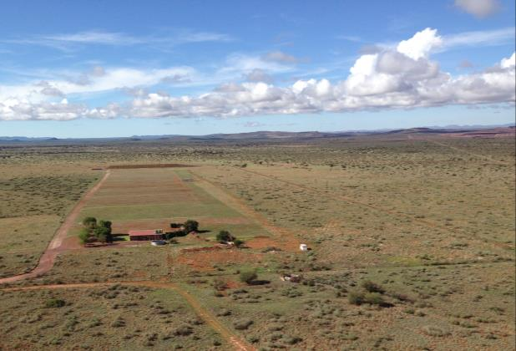
Figure 1: Agriculture
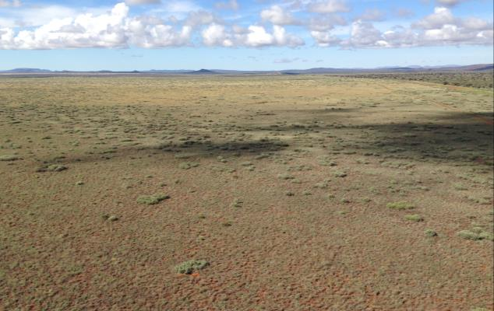
Figure 2: Savanna

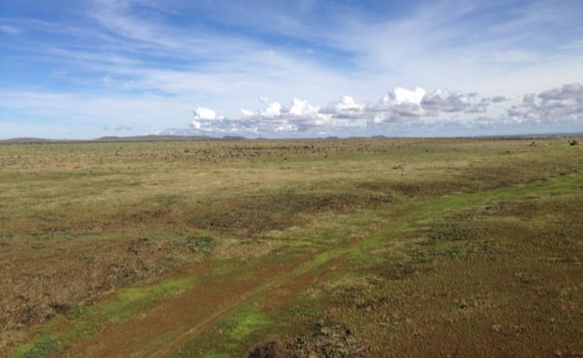
Figure 3: Dry riverbed
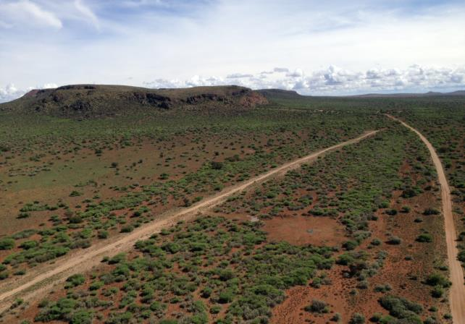
Figure 4: Ridges

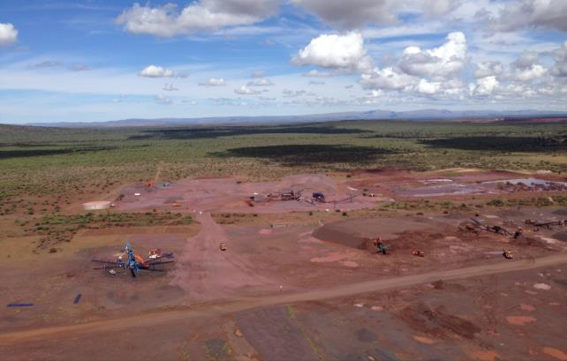
Figure 5: Industrial activity
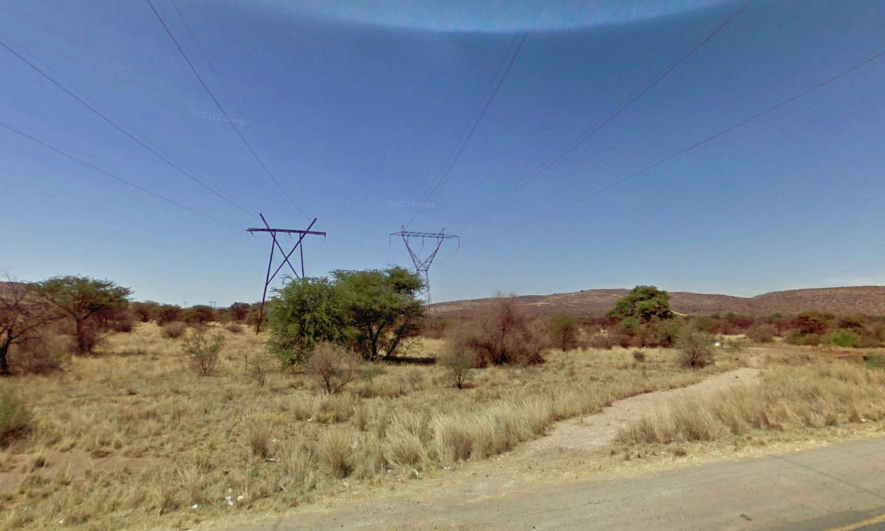
Figure 6: High voltage lines

APPENDIX 2: SPECIES SPECIFIC RISK RATINGS

Martial Eagle | Collisions | Disturbance | Habitat destruction | Red Data score | Reporting rate | Total
Urban | 0 | 0 | 0 | 3 | 2 | 0
Powerlines | -1 | 3 | 0 | 3 | 2 | 12
Ridges | 0 | 0 | 0 | 3 | 2 | 0
Wetlands and waterbodies | 1 | 0 | 0 | 3 | 2 | 6
Rivers | 0 | 0 | 0 | 3 | 2 | 0
Agriculture | 0 | 0 | 0 | 3 | 2 | 0
Vulture colonies | 0 | 0 | 0 | 3 | 2 | 0
Savanna | 1 | 1 | 0 | 3 | 2 | 12
Black Stork | Collisions | Disturbance | Habitat destruction | Red Data score | Reporting rate | Total
Urban | 0 | 0 | 0 | 3 | 2 | 0
Powerlines | -1 | 0 | 0 | 3 | 2 | -6
Ridges | 2 | 2 | 0 | 3 | 2 | 24
Wetlands and waterbodies | 3 | 2 | 1 | 3 | 2 | 36
Rivers | 2 | 1 | 0 | 3 | 2 | 18
Agriculture | 0 | 0 | 0 | 3 | 2 | 0
Vulture colonies | 0 | 0 | 0 | 3 | 2 | 0
Savanna | 0 | 0 | 0 | 3 | 2 | 0
Abdim's Stork | Collisions | Disturbance | Habitat destruction | Red Data score | Reporting rate | Total
Urban | 0 | 0 | 0 | 1 | 1 | 0
Powerlines | -1 | 0 | 0 | 1 | 1 | -1
Ridges | 0 | 0 | 0 | 1 | 1 | 0
Wetlands and waterbodies | 2 | 1 | 0 | 1 | 1 | 3
Rivers | 0 | 0 | 0 | 1 | 1 | 0
Agriculture | 3 | 2 | 0 | 1 | 1 | 5
Vulture colonies | 0 | 0 | 0 | 1 | 1 | 0
Savanna | 0 | 0 | 0 | 1 | 1 | 0
Lanner Falcon | Collisions | Disturbance | Habitat destruction | Red Data score | Reporting rate | Total
Urban | 0 | 0 | 0 | 2 | 1 | 0
Powerlines | -1 | 2 | 0 | 2 | 1 | 2
Ridges | 1 | 1 | 0 | 2 | 1 | 4
Wetlands and waterbodies | 0 | 0 | 0 | 2 | 1 | 0
Rivers | 0 | 0 | 0 | 2 | 1 | 0
Agriculture | 0 | 0 | 0 | 2 | 1 | 0
Vulture colonies | 0 | 0 | 0 | 2 | 1 | 0
Savanna | 0 | 0 | 0 | 2 | 1 | 0
Burchell's Courser | Collisions | Disturbance | Habitat destruction | Red Data score | Reporting rate | Total
Urban | 0 | 0 | 0 | 1 | 2 | 0
Powerlines | -1 | 0 | 0 | 1 | 2 | -2
Ridges | 0 | 0 | 0 | 1 | 2 | 0
Wetlands and waterbodies | 1 | 1 | 0 | 1 | 2 | 4
Rivers | 0 | 0 | 0 | 1 | 2 | 0
Agriculture | 1 | 1 | 0 | 1 | 2 | 4
Vulture colonies | 0 | 0 | 0 | 1 | 2 | 0
Savanna | 0 | 0 | 0 | 1 | 2 | 0

APPENDIX 3: ROUTE ALTERNATIVE RISK SCORES

Row Labels | Sum of Fin_Score | Sum of Habitat_score | Sum of Hectares
Man-Fer Alt 1 | 13.31 | 833 | 10719
Agriculture | 0.01 | 9 | 6
Ridges | 0.02 | 56 | 6
Rivers | 0.22 | 36 | 117
Savanna | 12.67 | 144 | 10000
Urban Industrial Roads | 0.00 | 0 | 507
Wetland Pan | 0.40 | 588 | 82
Man-Fer Alt 2 | 13.63 | 346 | 11023
Agriculture | 0.01 | 9 | 6
Ridges | 0.01 | 28 | 2
Rivers | 0.08 | 18 | 46
Savanna | 13.53 | 144 | 10784
Urban Industrial Roads | 0.00 | 0 | 183
Wetland Pan | 0.01 | 147 | 2
Grand Total | 26.94 | 1179 | 21742

HV lines posed a problem in that in some instances, the presence of an HV line in a specific habitat class could result in a reduction of the collision risk on the assumption that by placing the new line next to the existing line, the risk of collision for the new line is reduced. It was impractical to work out a risk score for each combination of HV line and habitat class for each species as this would be very onerous due to the many potential permutations. Instead it was decided to allow for a negative score where HV lines reduced the risk of collisions and treating it in the final comparative analysis of the different alternatives as an additive reduction to the risk score of the habitat class within which the line is situated.
Rivers, HV lines and major roads were buffered by 100m to create a corridor of which the surface area was then calculated.

